Chanukah & Yom Ha’atzmaut
Rabbi Moshe Shulman, Young Israel of St. Louis, 5768

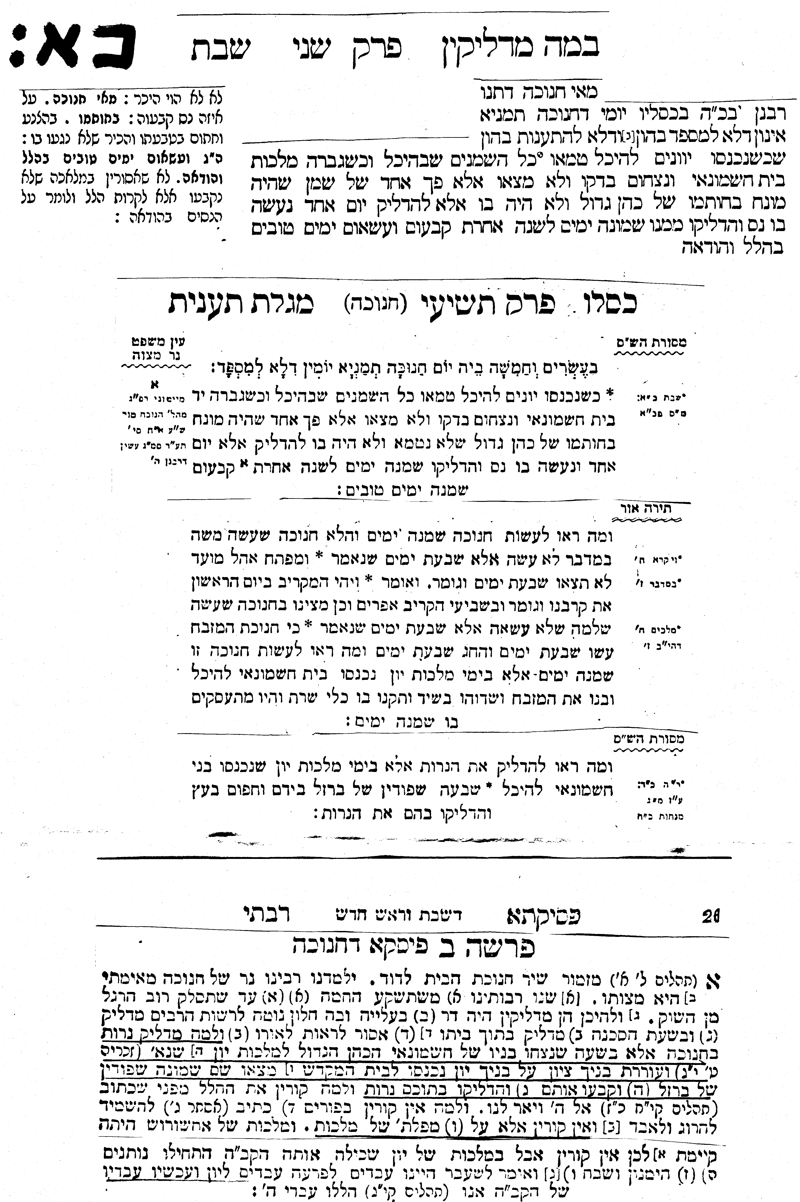

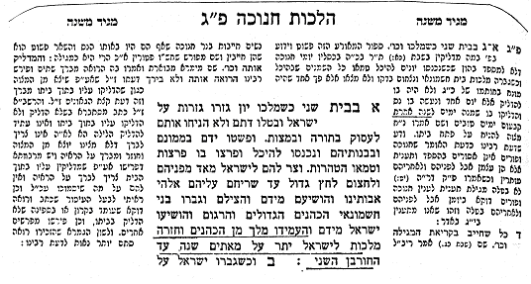

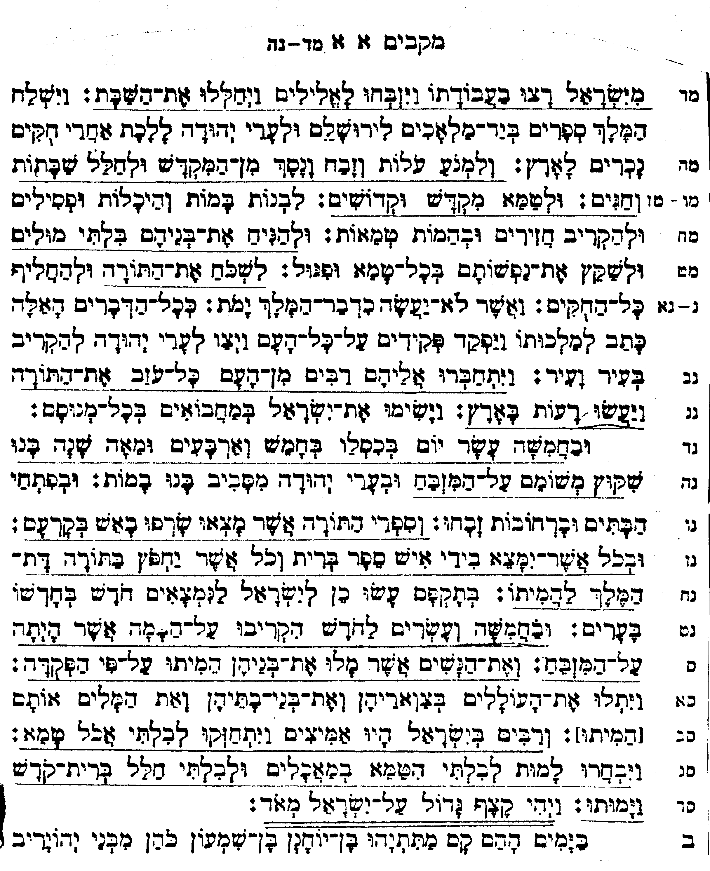
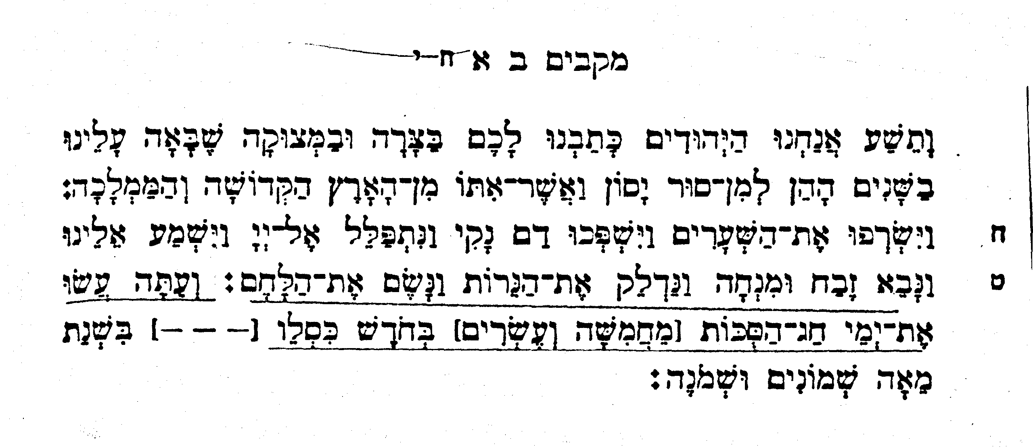
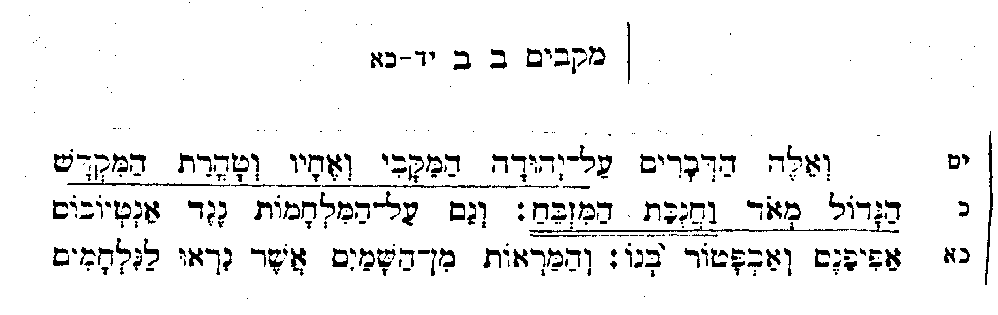
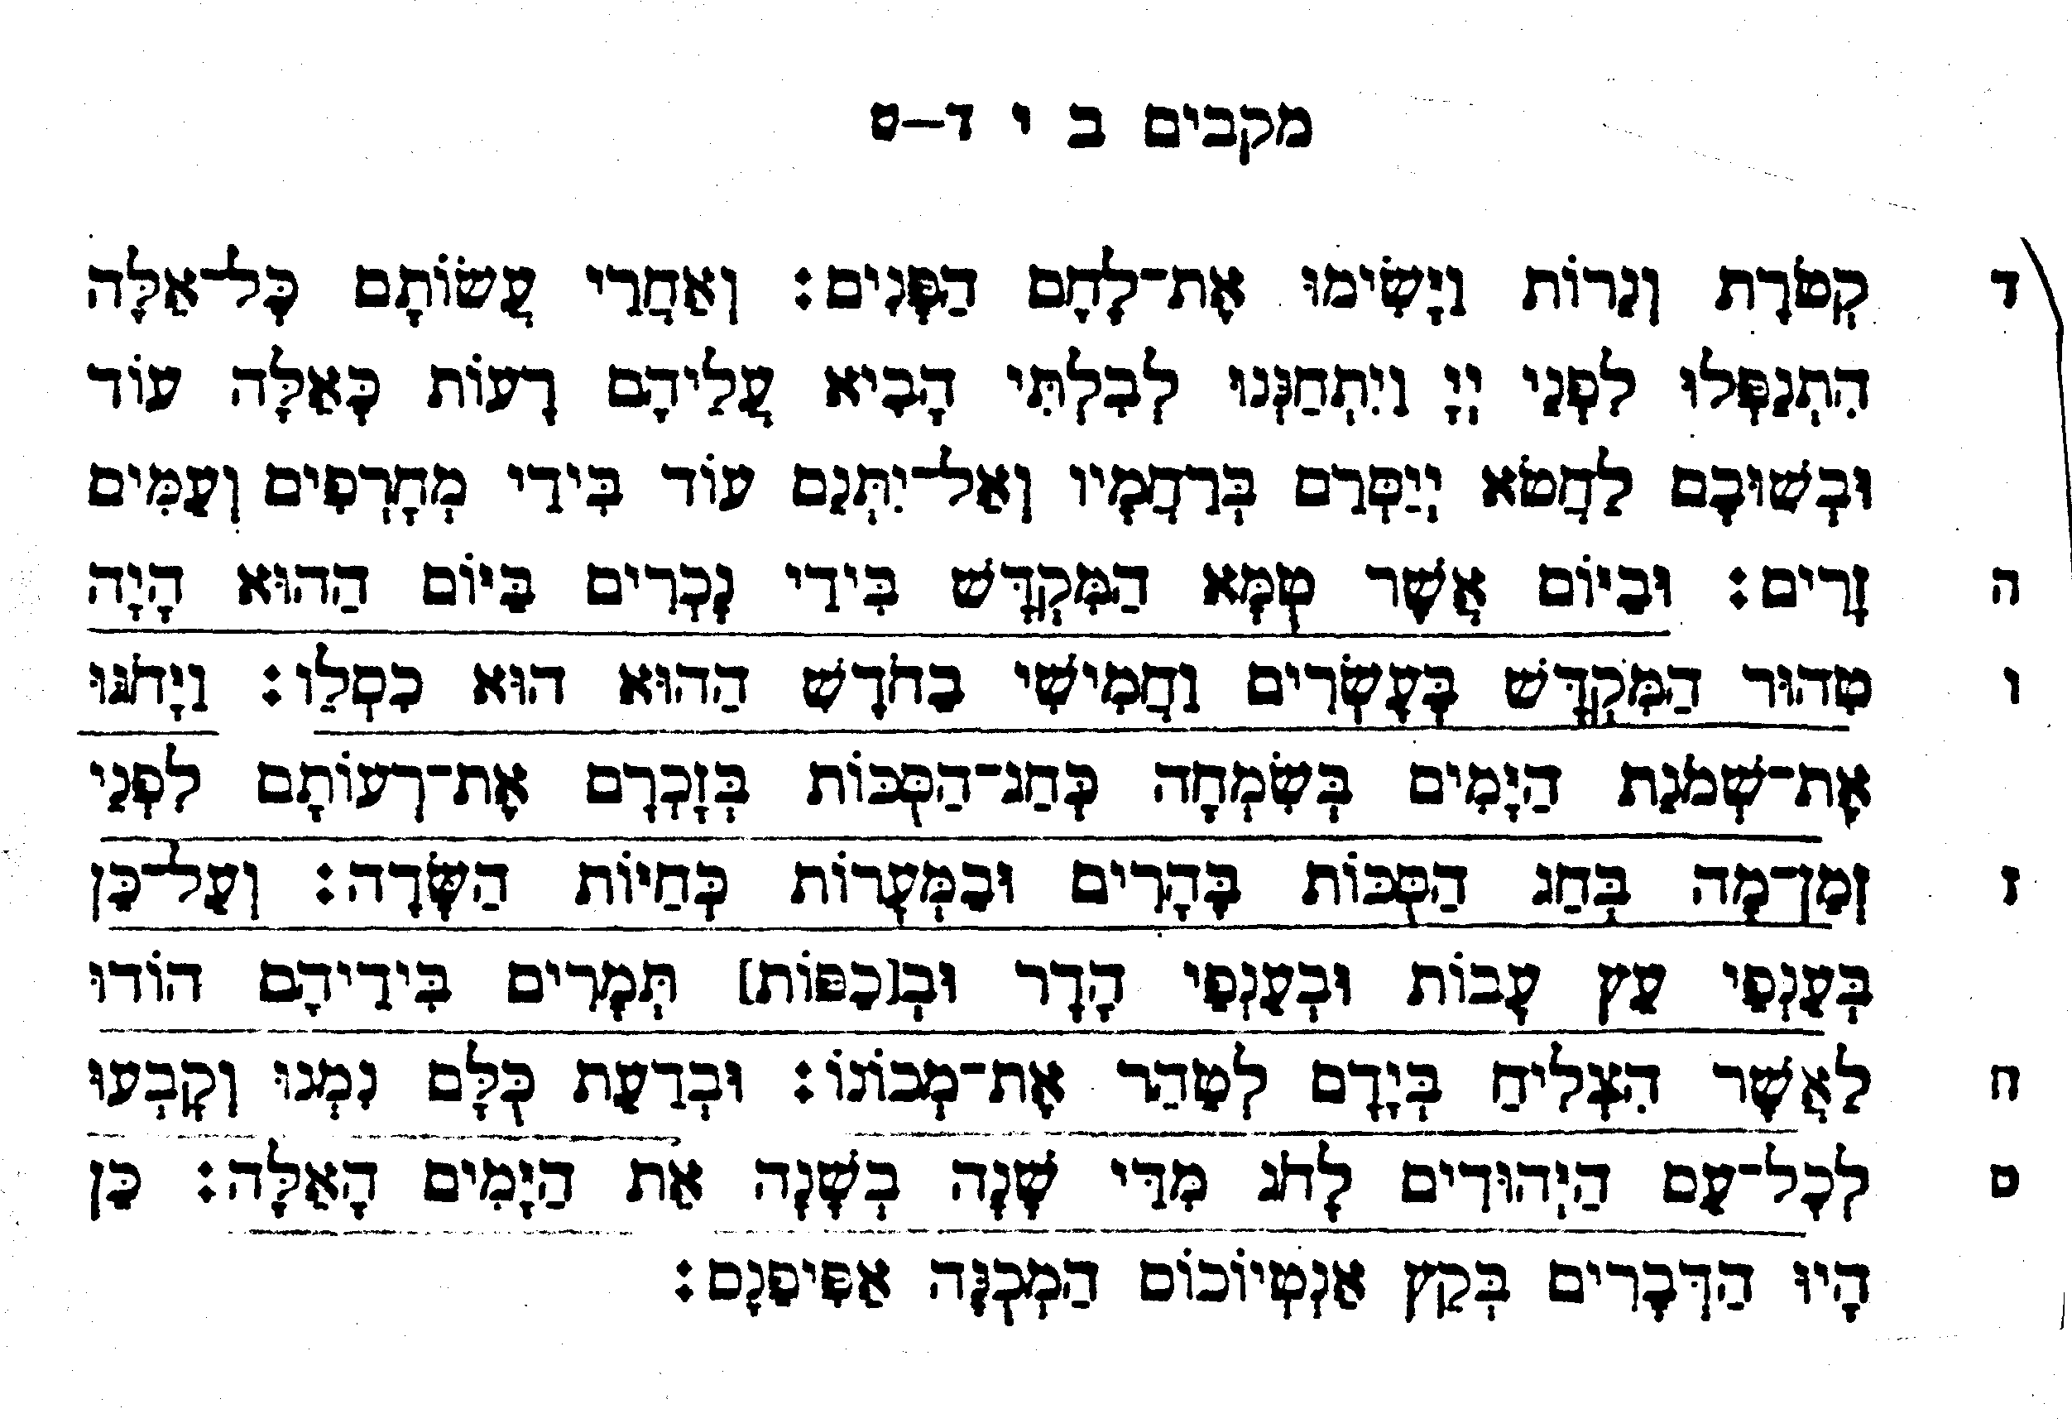
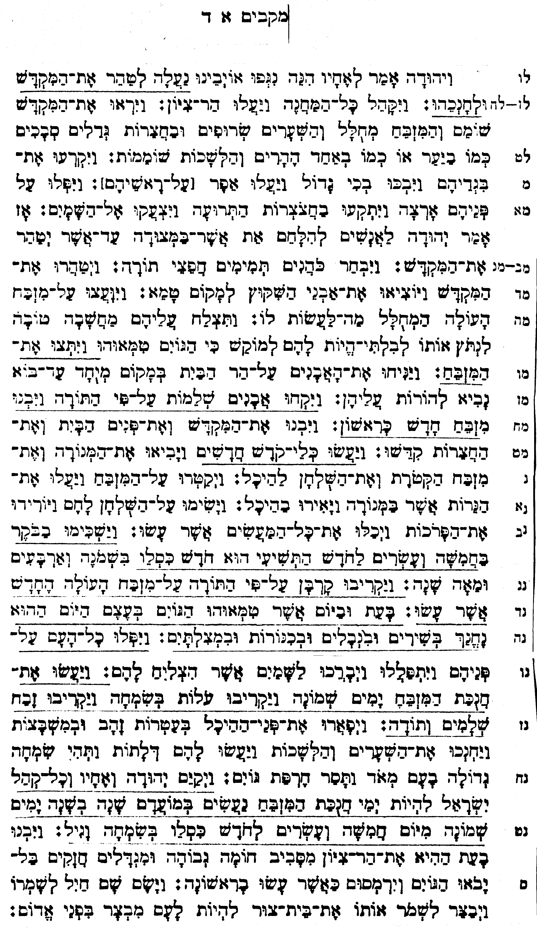

- Maccabees I:1
43: Yea, many also of the Israelites consented to his religion, and sacrificed unto idols, and profaned the sabbath. 44: For the king had sent letters by messengers unto Jerusalem and the cities of Juda that they should follow the strange laws of the land, 45: And forbid burnt offerings, and sacrifice, and drink offerings, in the temple; and that they should profane the sabbaths and festival days: 46: And pollute the sanctuary and holy people: 47: Set up altars, and groves, and chapels of idols, and sacrifice swine's flesh, and unclean beasts: 48: That they should also leave their children uncircumcised, and make their souls abominable with all manner of uncleanness and profanation: 49: To the end they might forget the law, and change all the ordinances. 50: And whosoever would not do according to the commandment of the king, he said, he should die. 51: In the selfsame manner wrote he to his whole kingdom, and appointed overseers over all the people, commanding the cities of Juda to sacrifice, city by city. 52: Then many of the people were gathered unto them, to wit every one that forsook the law; and so they committed evils in the land; 53: And drove the Israelites into secret places, even wheresoever they could flee for succour.
54: Now the fifteenth day of the month Casleu, in the hundred forty and fifth year, they set up the abomination of desolation upon the altar, and builded idol altars throughout the cities of Juda on every side; 55: And burnt incense at the doors of their houses, and in the streets. 56: And when they had rent in pieces the books of the law which they found, they burnt them with fire. 57: And whosoever was found with any the book of the testament, or if any committed to the law, the king's commandment was, that they should put him to death. 58: Thus did they by their authority unto the Israelites every month, to as many as were found in the cities. 59: Now the five and twentieth day of the month they did sacrifice upon the idol altar, which was upon the altar of God. 60: At which time according to the commandment they put to death certain women, that had caused their children to be circumcised. 61: And they hanged the infants about their necks, and rifled their houses, and slew them that had circumcised them. 62: Howbeit many in Israel were fully resolved and confirmed in themselves not to eat any unclean thing. 63: Wherefore the rather to die, that they might not be defiled with meats, and that they might not profane the holy covenant: so then they died. 64: And there was very great wrath upon Israel.

- Maccabees I:4
36: Then said Judas and his brethren, Behold, our enemies are discomfited: let us go up to cleanse and dedicate the sanctuary. 37: Upon this all the host assembled themselves together, and went up into mount Sion. 38: And when they saw the sanctuary desolate, and the altar profaned, and the gates burned up, and shrubs growing in the courts as in a forest, or in one of the mountains, yea, and the priests' chambers pulled down; 39: They rent their clothes, and made great lamentation, and cast ashes upon their heads, 40: And fell down flat to the ground upon their faces, and blew an alarm with the trumpets, and cried toward heaven. 41: Then Judas appointed certain men to fight against those that were in the fortress, until he had cleansed the sanctuary. 42: So he chose priests of blameless conversation, such as had pleasure in the law: 43: Who cleansed the sanctuary, and bare out the defiled stones into an unclean place. 44: And when as they consulted what to do with the altar of burnt offerings, which was profaned; 45: They thought it best to pull it down, lest it should be a reproach to them, because the heathen had defiled it: wherefore they pulled it down, 46: And laid up the stones in the mountain of the temple in a convenient place, until there should come a prophet to shew what should be done with them. 47: Then they took whole stones according to the law, and built a new altar according to the former; 48: And made up the sanctuary, and the things that were within the temple, and hallowed the courts. 49: They made also new holy vessels, and into the temple they brought the candlestick, and the altar of burnt offerings, and of incense, and the table. 50: And upon the altar they burned incense, and the lamps that were upon the candlestick they lighted, that they might give light in the temple. 51: Furthermore they set the loaves upon the table, and spread out the veils, and finished all the works which they had begun to make. 52: Now on the five and twentieth day of the ninth month, which is called the month Casleu, in the hundred forty and eighth year, they rose up betimes in the morning, 53: And offered sacrifice according to the law upon the new altar of burnt offerings, which they had made. 54: Look, at what time and what day the heathen had profaned it, even in that was it dedicated with songs, and citherns, and harps, and cymbals. 55: Then all the people fell upon their faces, worshipping and praising the God of heaven, who had given them good success. 56: And so they kept the dedication of the altar eight days and offered burnt offerings with gladness, and sacrificed the sacrifice of deliverance and praise. 57: They decked also the forefront of the temple with crowns of gold, and with shields; and the gates and the chambers they renewed, and hanged doors upon them. 58: Thus was there very great gladness among the people, for that the reproach of the heathen was put away. 59: Moreover Judas and his brethren with the whole congregation of Israel ordained, that the days of the dedication of the altar should be kept in their season from year to year by the space of eight days, from the five and twentieth day of the month Casleu, with mirth and gladness. 60: At that time also they builded up the mount Sion with high walls and strong towers round about, lest the Gentiles should come and tread it down as they had done before. 61: And they set there a garrison to keep it, and fortified Bethsura to preserve it; that the people might have a defence against Idumea.

- Maccabees II:1
7: What time as Demetrius reigned, in the hundred threescore and ninth year, we the Jews wrote unto you in the extremity of trouble that came upon us in those years, from the time that Jason and his company revolted from the holy land and kingdom, 8: And burned the porch, and shed innocent blood: then we prayed unto the Lord, and were heard; we offered also sacrifices and fine flour, and lighted the lamps, and set forth the loaves. 9: And now see that ye keep the feast of tabernacles in the month Casleu.

- Maccabees II:10
1: Now Maccabeus and his company, the Lord guiding them, recovered the temple and the city: 2: But the altars which the heathen had built in the open street, and also the chapels, they pulled down. 3: And having cleansed the temple they made another altar, and striking stones they took fire out of them, and offered a sacrifice after two years, and set forth incense, and lights, and shewbread. 4: When that was done, they fell flat down, and besought the Lord that they might come no more into such troubles; but if they sinned any more against him, that he himself would chasten them with mercy, and that they might not be delivered unto the blasphemous and barbarous nations. 5: Now upon the same day that the strangers profaned the temple, on the very same day it was cleansed again, even the five and twentieth day of the same month, which is Casleu. 6: And they kept the eight days with gladness, as in the feast of the tabernacles, remembering that not long afore they had held the feast of the tabernacles, when as they wandered in the mountains and dens like beasts. 7: Therefore they bare branches, and fair boughs, and palms also, and sang psalms unto him that had given them good success in cleansing his place. 8: They ordained also by a common statute and decree, That every year those days should be kept of the whole nation of the Jews. 9: And this was the end of Antiochus, called Epiphanes.
- עזרא פרק ג
(י) וְיִסְּדוּ הַבֹּנִים אֶת הֵיכַל ה' וַיַּעֲמִידוּ הַכֹּהֲנִים מְלֻבָּשִׁים בַּחֲצֹצְרוֹת וְהַלְוִיִּם בְּנֵי אָסָף בַּמְצִלְתַּיִם לְהַלֵּל אֶת ה' עַל יְדֵי דָּוִיד מֶלֶךְ יִשְׂרָאֵל: (יא) וַיַּעֲנוּ בְּהַלֵּל וּבְהוֹדֹת לַה' כִּי טוֹב כִּי לְעוֹלָם חַסְדּוֹ עַל יִשְׂרָאֵל וְכָל הָעָם הֵרִיעוּ תְרוּעָה גְדוֹלָה בְהַלֵּל לַה' עַל הוּסַד בֵּית ה': ס
(יב) וְרַבִּים מֵהַכֹּהֲנִים וְהַלְוִיִּם וְרָאשֵׁי הָאָבוֹת הַזְּקֵנִים אֲשֶׁר רָאוּ אֶת הַבַּיִת הָרִאשׁוֹן בְּיָסְדוֹ זֶה הַבַּיִת בְּעֵינֵיהֶם בֹּכִים בְּקוֹל גָּדוֹל וְרַבִּים בִּתְרוּעָה בְשִׂמְחָה לְהָרִים קוֹל: (יג) וְאֵין הָעָם מַכִּירִים קוֹל תְּרוּעַת הַשִּׂמְחָה לְקוֹל בְּכִי הָעָם כִּי הָעָם מְרִיעִים תְּרוּעָה גְדוֹלָה וְהַקּוֹל נִשְׁמַע עַד לְמֵרָחוֹק: פ

- שמות פרק כד
(טז) וַיִּשְׁכֹּן כְּבוֹד ה' עַל הַר סִינַי וַיְכַסֵּהוּ הֶעָנָן שֵׁשֶׁת יָמִים וַיִּקְרָא אֶל מֹשֶׁה בַּיּוֹם הַשְּׁבִיעִי מִתּוֹךְ הֶעָנָן: (יז) וּמַרְאֵה כְּבוֹד ה' כְּאֵשׁ אֹכֶלֶת בְּרֹאשׁ הָהָר לְעֵינֵי בְּנֵי יִשְׂרָאֵל:

- שמות פרק מ
(לד) וַיְכַס הֶעָנָן אֶת אֹהֶל מוֹעֵד וּכְבוֹד ה' מָלֵא אֶת הַמִּשְׁכָּן:

- ויקרא פרק ט
(ו) וַיֹּאמֶר מֹשֶׁה זֶה הַדָּבָר אֲשֶׁר צִוָּה ה' תַּעֲשׂוּ וְיֵרָא אֲלֵיכֶם כְּבוֹד ה'.

- מלכים א פרק ח
(טז) מִן הַיּוֹם אֲשֶׁר הוֹצֵאתִי אֶת עַמִּי אֶת יִשְׂרָאֵל מִמִּצְרַיִם לֹא בָחַרְתִּי בְעִיר מִכֹּל שִׁבְטֵי יִשְׂרָאֵל לִבְנוֹת בַּיִת לִהְיוֹת שְׁמִי שָׁם וָאֶבְחַר בְּדָוִד לִהְיוֹת עַל עַמִּי יִשְׂרָאֵל:

- שמואל ב פרק ז
(ה) לֵךְ וְאָמַרְתָּ אֶל עַבְדִּי אֶל דָּוִד כֹּה אָמַר ה' הַאַתָּה תִּבְנֶה לִּי בַיִת לְשִׁבְתִּי: (ו) כִּי לֹא יָשַׁבְתִּי בְּבַיִת לְמִיּוֹם הַעֲלֹתִי אֶת בְּנֵי יִשְׂרָאֵל מִמִּצְרַיִם וְעַד הַיּוֹם הַזֶּה וָאֶהְיֶה מִתְהַלֵּךְ בְּאֹהֶל וּבְמִשְׁכָּן: (ז) בְּכֹל אֲשֶׁר הִתְהַלַּכְתִּי בְּכָל בְּנֵי יִשְׂרָאֵל הֲדָבָר דִּבַּרְתִּי אֶת אַחַד שִׁבְטֵי יִשְׂרָאֵל אֲשֶׁר צִוִּיתִי לִרְעוֹת אֶת עַמִּי אֶת יִשְׂרָאֵל לֵאמֹר לָמָּה לֹא בְנִיתֶם לִי בֵּית אֲרָזִים:
(ח) וְעַתָּה כֹּה תֹאמַר לְעַבְדִּי לְדָוִד כֹּה אָמַר ה' צְבָאוֹת אֲנִי לְקַחְתִּיךָ מִן הַנָּוֶה מֵאַחַר הַצֹּאן לִהְיוֹת נָגִיד עַל עַמִּי עַל יִשְׂרָאֵל: (ט) וָאֶהְיֶה עִמְּךָ בְּכֹל אֲשֶׁר הָלַכְתָּ וָאַכְרִתָה אֶת כָּל אֹיְבֶיךָ מִפָּנֶיךָ וְעָשִׂתִי לְךָ שֵׁם גָּדוֹל כְּשֵׁם הַגְּדֹלִים אֲשֶׁר בָּאָרֶץ: (י) וְשַׂמְתִּי מָקוֹם לְעַמִּי לְיִשְׂרָאֵל וּנְטַעְתִּיו וְשָׁכַן תַּחְתָּיו וְלֹא יִרְגַּז עוֹד וְלֹא יֹסִיפוּ בְנֵי עַוְלָה לְעַנּוֹתוֹ כַּאֲשֶׁר בָּרִאשׁוֹנָה: (יא) וּלְמִן הַיּוֹם אֲשֶׁר צִוִּיתִי שֹׁפְטִים עַל עַמִּי יִשְׂרָאֵל וַהֲנִיחֹתִי לְךָ מִכָּל אֹיְבֶיךָ וְהִגִּיד לְךָ ה' כִּי בַיִת יַעֲשֶׂה לְּךָ ה': (יב) כִּי יִמְלְאוּ יָמֶיךָ וְשָׁכַבְתָּ אֶת אֲבֹתֶיךָ וַהֲקִימֹתִי אֶת זַרְעֲךָ אַחֲרֶיךָ אֲשֶׁר יֵצֵא מִמֵּעֶיךָ וַהֲכִינֹתִי אֶת מַמְלַכְתּוֹ:
(יג) הוּא יִבְנֶה בַּיִת לִשְׁמִי וְכֹנַנְתִּי אֶת כִּסֵּא מַמְלַכְתּוֹ עַד עוֹלָם: (יד) אֲנִי אֶהְיֶה לּוֹ לְאָב וְהוּא יִהְיֶה לִּי לְבֵן אֲשֶׁר בְּהַעֲוֹתוֹ וְהֹכַחְתִּיו בְּשֵׁבֶט אֲנָשִׁים וּבְנִגְעֵי בְּנֵי אָדָם: (טו) וְחַסְדִּי לֹא יָסוּר מִמֶּנּוּ כַּאֲשֶׁר הֲסִרֹתִי מֵעִם שָׁאוּל אֲשֶׁר הֲסִרֹתִי מִלְּפָנֶיךָ: (טז) וְנֶאְמַן בֵּיתְךָ וּמַמְלַכְתְּךָ עַד עוֹלָם לְפָנֶיךָ כִּסְאֲךָ יִהְיֶה נָכוֹן עַד עוֹלָם: (יז) כְּכֹל הַדְּבָרִים הָאֵלֶּה וּכְכֹל הַחִזָּיוֹן הַזֶּה כֵּן דִּבֶּר נָתָן אֶל דָּוִד: ס

- דברי הימים א פרק כט  (כג) וַיֵּשֶׁב שְׁלֹמֹה עַל כִּסֵּא ה' לְמֶלֶךְ תַּחַת דָּוִיד אָבִיו וַיַּצְלַח וַיִּשְׁמְעוּ אֵלָיו כָּל יִשְׂרָאֵל: | - מלכים א פרק ב פסוק יב  וּשְׁלֹמֹה יָשַׁב עַל כִּסֵּא דָּוִד אָבִיו וַתִּכֹּן מַלְכֻתוֹ מְאֹד:

- זכריה פרק ד
(א) וַיָּשָׁב הַמַּלְאָךְ הַדֹּבֵר בִּי וַיְעִירֵנִי כְּאִישׁ אֲשֶׁר יֵעוֹר מִשְּׁנָתוֹ: (ב) וַיֹּאמֶר אֵלַי מָה אַתָּה רֹאֶה וָאֹמַר רָאִיתִי וְהִנֵּה מְנוֹרַת זָהָב כֻּלָּהּ וְגֻלָּהּ עַל רֹאשָׁהּ וְשִׁבְעָה נֵרֹתֶיהָ עָלֶיהָ שִׁבְעָה וְשִׁבְעָה מוּצָקוֹת לַנֵּרוֹת אֲשֶׁר עַל רֹאשָׁהּ: (ג) וּשְׁנַיִם זֵיתִים עָלֶיהָ אֶחָד מִימִין הַגֻּלָּה וְאֶחָד עַל שְׂמֹאלָהּ: (ד) וָאַעַן וָאֹמַר אֶל הַמַּלְאָךְ הַדֹּבֵר בִּי לֵאמֹר מָה אֵלֶּה אֲדֹנִי: (ה) וַיַּעַן הַמַּלְאָךְ הַדֹּבֵר בִּי וַיֹּאמֶר אֵלַי הֲלוֹא יָדַעְתָּ מָה הֵמָּה אֵלֶּה וָאֹמַר לֹא אֲדֹנִי: (ו) וַיַּעַן וַיֹּאמֶר אֵלַי לֵאמֹר זֶה דְּבַר ה' אֶל זְרֻבָּבֶל לֵאמֹר לֹא בְחַיִל וְלֹא בְכֹחַ כִּי אִם בְּרוּחִי אָמַר ה' צְבָאוֹת: (ז) מִי אַתָּה הַר הַגָּדוֹל לִפְנֵי זְרֻבָּבֶל לְמִישֹׁר וְהוֹצִיא אֶת הָאֶבֶן הָרֹאשָׁה תְּשֻׁאוֹת חֵן חֵן לָהּ: פ (ח) וַיְהִי דְבַר ה' אֵלַי לֵאמֹר: (ט) יְדֵי זְרֻבָּבֶל יִסְּדוּ הַבַּיִת הַזֶּה וְיָדָיו תְּבַצַּעְנָה וְיָדַעְתָּ כִּי ה' צְבָאוֹת שְׁלָחַנִי אֲלֵיכֶם: (י) כִּי מִי בַז לְיוֹם קְטַנּוֹת וְשָׂמְחוּ וְרָאוּ אֶת הָאֶבֶן הַבְּדִיל בְּיַד זְרֻבָּבֶל שִׁבְעָה אֵלֶּה עֵינֵי ה' הֵמָּה מְשׁוֹטְטִים בְּכָל הָאָרֶץ: (יא) וָאַעַן וָאֹמַר אֵלָיו מַה שְּׁנֵי הַזֵּיתִים הָאֵלֶּה עַל יְמִין הַמְּנוֹרָה וְעַל שְׂמֹאולָהּ: (יב) וָאַעַן שֵׁנִית וָאֹמַר אֵלָיו מַה שְׁתֵּי שִׁבֲּלֵי הַזֵּיתִים אֲשֶׁר בְּיַד שְׁנֵי צַנְתְּרוֹת הַזָּהָב הַמְרִיקִים מֵעֲלֵיהֶם הַזָּהָב: (יג) וַיֹּאמֶר אֵלַי לֵאמֹר הֲלוֹא יָדַעְתָּ מָה אֵלֶּה וָאֹמַר לֹא אֲדֹנִי: (יד) וַיֹּאמֶר אֵלֶּה שְׁנֵי בְנֵי הַיִּצְהָר הָעֹמְדִים עַל אֲדוֹן כָּל הָאָרֶץ:

- דברי הימים ב פרק ה
(יא) וַיְהִי בְּצֵאת הַכֹּהֲנִים מִן הַקֹּדֶשׁ כִּי כָּל הַכֹּהֲנִים הַנִּמְצְאִים הִתְקַדָּשׁוּ אֵין לִשְׁמוֹר לְמַחְלְקוֹת: (יב) וְהַלְוִיִּם הַמְשֹׁרֲרִים לְכֻלָּם לְאָסָף לְהֵימָן לִידֻתוּן וְלִבְנֵיהֶם וְלַאֲחֵיהֶם מְלֻבָּשִׁים בּוּץ בִּמְצִלְתַּיִם וּבִנְבָלִים וְכִנֹּרוֹת עֹמְדִים מִזְרָח לַמִּזְבֵּחַ וְעִמָּהֶם כֹּהֲנִים לְמֵאָה וְעֶשְׂרִים <מחצררים> מַחְצְרִים בַּחֲצֹצְרוֹת: (יג) וַיְהִי כְאֶחָד לַמְחַצְּרִים וְלַמְשֹׁרֲרִים לְהַשְׁמִיעַ קוֹל אֶחָד לְהַלֵּל וּלְהֹדוֹת לַה' וּכְהָרִים קוֹל בַּחֲצֹצְרוֹת וּבִמְצִלְתַּיִם וּבִכְלֵי הַשִּׁיר וּבְהַלֵּל לַה' כִּי טוֹב כִּי לְעוֹלָם חַסְדּוֹ וְהַבַּיִת מָלֵא עָנָן בֵּית ה': (יד) וְלֹא יָכְלוּ הַכֹּהֲנִים לַעֲמוֹד לְשָׁרֵת מִפְּנֵי הֶעָנָן כִּי מָלֵא כְבוֹד ה' אֶת בֵּית הָאֱלֹהִים:

- דברי הימים ב פרק ז
(א) וּכְכַלּוֹת שְׁלֹמֹה לְהִתְפַּלֵּל וְהָאֵשׁ יָרְדָה מֵהַשָּׁמַיִם וַתֹּאכַל הָעֹלָה וְהַזְּבָחִים וּכְבוֹד ה' מָלֵא אֶת הַבָּיִת: (ב) וְלֹא יָכְלוּ הַכֹּהֲנִים לָבוֹא אֶל בֵּית ה' כִּי מָלֵא כְבוֹד ה' אֶת בֵּית ה': (ג) וְכֹל בְּנֵי יִשְׂרָאֵל רֹאִים בְּרֶדֶת הָאֵשׁ וּכְבוֹד ה' עַל הַבָּיִת וַיִּכְרְעוּ אַפַּיִם אַרְצָה עַל הָרִצְפָה וַיִּשְׁתַּחֲווּ וְהוֹדוֹת לַה' כִּי טוֹב כִּי לְעוֹלָם חַסְדּוֹ: (ד) וְהַמֶּלֶךְ וְכָל הָעָם זֹבְחִים זֶבַח לִפְנֵי ה':

1: In the second year of Darius the king, in the sixth month, on the first day of the month, the word of the LORD came by Haggai the prophet to Zerub'babel the son of She-al'ti-el, governor of Judah, and to Joshua the son of Jehoz'adak, the high priest, 2: "Thus says the LORD of hosts: This people say the time has not yet come to rebuild the house of the LORD."  3: Then the word of the LORD came by Haggai the prophet, 4: "Is it a time for you yourselves to dwell in your paneled houses, while this house lies in ruins? 5: Now therefore thus says the LORD of hosts: Consider how you have fared. 6: You have sown much, and harvested little; you eat, but you never have enough; you drink, but you never have your fill; you clothe yourselves, but no one is warm; and he who earns wages earns wages to put them into a bag with holes.  7: "Thus says the LORD of hosts: Consider how you have fared. 8: Go up to the hills and bring wood and build the house, that I may take pleasure in it and that I may appear in my glory, says the LORD. 9: You have looked for much, and, lo, it came to little; and when you brought it home, I blew it away. Why? says the LORD of hosts. Because of my house that lies in ruins, while you busy yourselves each with his own house. 10: Therefore the heavens above you have withheld the dew, and the earth has withheld its produce. 11: And I have called for a drought upon the land and the hills, upon the grain, the new wine, the oil, upon what the ground brings forth, upon men and cattle, and upon all their labors." 12: Then Zerub'babel the son of She-al'ti-el, and Joshua the son of Jehoz'adak, the high priest, with all the remnant of the people, obeyed the voice of the LORD their God, and the words of Haggai the prophet, as the LORD their God had sent him; and the people feared before the LORD.  13: Then Haggai, the messenger of the LORD, spoke to the people with the LORD's message, "I am with you, says the LORD." 14: And the LORD stirred up the spirit of Zerub'babel the son of She-al'ti-el, governor of Judah, and the spirit of Joshua the son of Jehoz'adak, the high priest, and the spirit of all the remnant of the people; and they came and worked on the house of the LORD of hosts, their God, 15: on the twenty-fourth day of the month, in the sixth month. In the second year of Darius the king,  CHAPTER 2  1: In the seventh month, on the twenty-first day of the month, the word of the LORD came by Haggai the prophet, 2: "Speak now to Zerub'babel the son of She-al'ti-el, governor of Judah, and to Joshua the son of Jehoz'adak, the high priest, and to all the remnant of the people, and say, 3: `Who is left among you that saw this house in its former glory? How do you see it now? Is it not in your sight as nothing? 4: Yet now take courage, O Zerub'babel, says the LORD; take courage, O Joshua, son of Jehoz'adak, the high priest; take courage, all you people of the land, says the LORD; work, for I am with you, says the LORD of hosts, 5: according to the promise that I made you when you came out of Egypt. My Spirit abides among you; fear not.  6: For thus says the LORD of hosts: Once again, in a little while, I will shake the heavens and the earth and the sea and the dry land; 7: and I will shake all nations, so that the treasures of all nations shall come in, and I will fill this house with splendor, says the LORD of hosts. 8: The silver is mine, and the gold is mine, says the LORD of hosts. 9: The latter splendor of this house shall be greater than the former, says the LORD of hosts; and in this place I will give prosperity, says the LORD of hosts.'"  10: On the twenty-fourth day of the ninth month, in the second year of Darius, the word of the LORD came by Haggai the prophet, 11: "Thus says the LORD of hosts: Ask the priests to decide this question, 12: `If one carries holy flesh in the skirt of his garment, and touches with his skirt bread, or pottage, or wine, or oil, or any kind of food, does it become holy?'" The priests answered, "No." 13: Then said Haggai, "If one who is unclean by contact with a dead body touches any of these, does it become unclean?" The priests answered, "It does become unclean." 14: Then Haggai said, "So is it with this people, and with this nation before me, says the LORD; and so with every work of their hands; and what they offer there is unclean. 15: Pray now, consider what will come to pass from this day onward. Before a stone was placed upon a stone in the temple of the LORD, 16: how did you fare? When one came to a heap of twenty measures, there were but ten; when one came to the winevat to draw fifty measures, there were but twenty. 17: I smote you and all the products of your toil with blight and mildew and hail; yet you did not return to me, says the LORD. 18: Consider from this day onward, from the twenty-fourth day of the ninth month. Since the day that the foundation of the LORD's temple was laid, consider: 19: Is the seed yet in the barn? Do the vine, the fig tree, the pomegranate, and the olive tree still yield nothing? From this day on I will bless you."  20: The word of the LORD came a second time to Haggai on the twenty-fourth day of the month, 21: "Speak to Zerub'babel, governor of Judah, saying, I am about to shake the heavens and the earth, 22: and to overthrow the throne of kingdoms; I am about to destroy the strength of the kingdoms of the nations, and overthrow the chariots and their riders; and the horses and their riders shall go down, every one by the sword of his fellow. 23: On that day, says the LORD of hosts, I will take you, O Zerub'babel my servant, the son of She-al'ti-el, says the LORD, and make you like a signet ring; for I have chosen you, says the LORD of hosts." | - ספר חגי פרק א  (א) בִּשְׁנַת שְׁתַּיִם לְדָרְיָוֶשׁ הַמֶּלֶךְ בַּחֹדֶשׁ הַשִּׁשִּׁי בְּיוֹם אֶחָד לַחֹדֶשׁ הָיָה דְבַר ה' בְּיַד חַגַּי הַנָּבִיא אֶל זְרֻבָּבֶל בֶּן שְׁאַלְתִּיאֵל פַּחַת יְהוּדָה וְאֶל יְהוֹשֻׁעַ בֶּן יְהוֹצָדָק הַכֹּהֵן הַגָּדוֹל לֵאמֹר: (ב) כֹּה אָמַר ה' צְבָאוֹת לֵאמֹר הָעָם הַזֶּה אָמְרוּ לֹא עֶת בֹּא עֶת בֵּית ה' לְהִבָּנוֹת:  (ג) וַיְהִי דְּבַר ה' בְּיַד חַגַּי הַנָּבִיא לֵאמֹר: (ד) הַעֵת לָכֶם אַתֶּם לָשֶׁבֶת בְּבָתֵּיכֶם סְפוּנִים וְהַבַּיִת הַזֶּה חָרֵב: (ה) וְעַתָּה כֹּה אָמַר ה' צְבָאוֹת שִׂימוּ לְבַבְכֶם עַל דַּרְכֵיכֶם: (ו) זְרַעְתֶּם הַרְבֵּה וְהָבֵא מְעָט אָכוֹל וְאֵין לְשָׂבְעָה שָׁתוֹ וְאֵין לְשָׁכְרָה לָבוֹשׁ וְאֵין לְחֹם לוֹ וְהַמִּשְׂתַּכֵּר מִשְׂתַּכֵּר אֶל צְרוֹר נָקוּב:  (ז) כֹּה אָמַר ה' צְבָאוֹת שִׂימוּ לְבַבְכֶם עַל דַּרְכֵיכֶם: (ח) עֲלוּ הָהָר וַהֲבֵאתֶם עֵץ וּבְנוּ הַבָּיִת וְאֶרְצֶה בּוֹ וְאֶכָּבְדָ }וְאֶכָּבְדָה{ אָמַר ה': (ט) פָּנֹה אֶל הַרְבֵּה וְהִנֵּה לִמְעָט וַהֲבֵאתֶם הַבַּיִת וְנָפַחְתִּי בוֹ יַעַן מֶה נְאֻם ה' צְבָאוֹת יַעַן בֵּיתִי אֲשֶׁר הוּא חָרֵב וְאַתֶּם רָצִים אִישׁ לְבֵיתוֹ: (י) עַל כֵּן עֲלֵיכֶם כָּלְאוּ שָׁמַיִם מִטָּל וְהָאָרֶץ כָּלְאָה יְבוּלָהּ: (יא) וָאֶקְרָא חֹרֶב עַל הָאָרֶץ וְעַל הֶהָרִים וְעַל הַדָּגָן וְעַל הַתִּירוֹשׁ וְעַל הַיִּצְהָר וְעַל אֲשֶׁר תּוֹצִיא הָאֲדָמָה וְעַל הָאָדָם וְעַל הַבְּהֵמָה וְעַל כָּל יְגִיעַ כַּפָּיִם:  (יב) וַיִּשְׁמַע זְרֻבָּבֶל בֶּן שַׁלְתִּיאֵל וִיהוֹשֻׁעַ בֶּן יְהוֹצָדָק הַכֹּהֵן הַגָּדוֹל וְכֹל שְׁאֵרִית הָעָם בְּקוֹל ה' אֱלֹהֵיהֶם וְעַל דִּבְרֵי חַגַּי הַנָּבִיא כַּאֲשֶׁר שְׁלָחוֹ ה' אֱלֹהֵיהֶם וַיִּירְאוּ הָעָם מִפְּנֵי ה':  (יג) וַיֹּאמֶר חַגַּי מַלְאַךְ ה' בְּמַלְאֲכוּת ה' לָעָם לֵאמֹר אֲנִי אִתְּכֶם נְאֻם ה': (יד) וַיָּעַר ה' אֶת רוּחַ זְרֻבָּבֶל בֶּן שַׁלְתִּיאֵל פַּחַת יְהוּדָה וְאֶת רוּחַ יְהוֹשֻׁעַ בֶּן יְהוֹצָדָק הַכֹּהֵן הַגָּדוֹל וְאֶת רוּחַ כֹּל שְׁאֵרִית הָעָם וַיָּבֹאוּ וַיַּעֲשׂוּ מְלָאכָה בְּבֵית ה' צְבָאוֹת אֱלֹהֵיהֶם:  (טו) בְּיוֹם עֶשְׂרִים וְאַרְבָּעָה לַחֹדֶשׁ בַּשִּׁשִּׁי בִּשְׁנַת שְׁתַּיִם לְדָרְיָוֶשׁ הַמֶּלֶךְ:  ספר חגי פרק ב  (א) בַּשְּׁבִיעִי בְּעֶשְׂרִים וְאֶחָד לַחֹדֶשׁ הָיָה דְּבַר ה' בְּיַד חַגַּי הַנָּבִיא לֵאמֹר: (ב) אֱמָר נָא אֶל זְרֻבָּבֶל בֶּן שַׁלְתִּיאֵל פַּחַת יְהוּדָה וְאֶל יְהוֹשֻׁעַ בֶּן יְהוֹצָדָק הַכֹּהֵן הַגָּדוֹל וְאֶל שְׁאֵרִית הָעָם לֵאמֹר: (ג) מִי בָכֶם הַנִּשְׁאָר אֲשֶׁר רָאָה אֶת הַבַּיִת הַזֶּה בִּכְבוֹדוֹ הָרִאשׁוֹן וּמָה אַתֶּם רֹאִים אֹתוֹ עַתָּה הֲלוֹא כָמֹהוּ כְּאַיִן בְּעֵינֵיכֶם: (ד) וְעַתָּה חֲזַק זְרֻבָּבֶל נְאֻם ה' וַחֲזַק יְהוֹשֻׁעַ בֶּן יְהוֹצָדָק הַכֹּהֵן הַגָּדוֹל וַחֲזַק כָּל עַם הָאָרֶץ נְאֻם ה' וַעֲשׂוּ כִּי אֲנִי אִתְּכֶם נְאֻם ה' צְבָאוֹת: (ה) אֶת הַדָּבָר אֲשֶׁר כָּרַתִּי אִתְּכֶם בְּצֵאתְכֶם מִמִּצְרַיִם וְרוּחִי עֹמֶדֶת בְּתוֹכְכֶם אַל תִּירָאוּ:  (ו) כִּי כֹה אָמַר ה' צְבָאוֹת עוֹד אַחַת מְעַט הִיא וַאֲנִי מַרְעִישׁ אֶת הַשָּׁמַיִם וְאֶת הָאָרֶץ וְאֶת הַיָּם וְאֶת הֶחָרָבָה: (ז) וְהִרְעַשְׁתִּי אֶת כָּל הַגּוֹיִם וּבָאוּ חֶמְדַּת כָּל הַגּוֹיִם וּמִלֵּאתִי אֶת הַבַּיִת הַזֶּה כָּבוֹד אָמַר ה' צְבָאוֹת: (ח) לִי הַכֶּסֶף וְלִי הַזָּהָב נְאֻם ה' צְבָאוֹת:(ט) גָּדוֹל יִהְיֶה כְּבוֹד הַבַּיִת הַזֶּה הָאַחֲרוֹן מִן הָרִאשׁוֹן אָמַר ה' צְבָאוֹת וּבַמָּקוֹם הַזֶּה אֶתֵּן שָׁלוֹם נְאֻם ה' צְבָאוֹת:  (י) בְּעֶשְׂרִים וְאַרְבָּעָה לַתְּשִׁיעִי בִּשְׁנַת שְׁתַּיִם לְדָרְיָוֶשׁ הָיָה דְּבַר ה' בְּיַד חַגַּי הַנָּבִיא לֵאמֹר: (יא) כֹּה אָמַר ה' צְבָאוֹת שְׁאַל נָא אֶת הַכֹּהֲנִים תּוֹרָה לֵאמֹר: (יב) הֵן יִשָּׂא אִישׁ בְּשַׂר קֹדֶשׁ בִּכְנַף בִּגְדוֹ וְנָגַע בִּכְנָפוֹ אֶל הַלֶּחֶם וְאֶל הַנָּזִיד וְאֶל הַיַּיִן וְאֶל שֶׁמֶן וְאֶל כָּל מַאֲכָל הֲיִקְדָּשׁ וַיַּעֲנוּ הַכֹּהֲנִים וַיֹּאמְרוּ לֹא: (יג) וַיֹּאמֶר חַגַּי אִם יִגַּע טְמֵא נֶפֶשׁ בְּכָל אֵלֶּה הֲיִטְמָא וַיַּעֲנוּ הַכֹּהֲנִים וַיֹּאמְרוּ יִטְמָא: (יד) וַיַּעַן חַגַּי וַיֹּאמֶר כֵּן הָעָם הַזֶּה וְכֵן הַגּוֹי הַזֶּה לְפָנַי נְאֻם ה' וְכֵן כָּל מַעֲשֵׂה יְדֵיהֶם וַאֲשֶׁר יַקְרִיבוּ שָׁם טָמֵא הוּא: (טו) וְעַתָּה שִׂימוּ נָא לְבַבְכֶם מִן הַיּוֹם הַזֶּה וָמָעְלָה מִטֶּרֶם שׂוּם אֶבֶן אֶל אֶבֶן בְּהֵיכַל ה': (טז) מִהְיוֹתָם בָּא אֶל עֲרֵמַת עֶשְׂרִים וְהָיְתָה עֲשָׂרָה בָּא אֶל הַיֶּקֶב לַחְשׂף חֲמִשִּׁים פּוּרָה וְהָיְתָה עֶשְׂרִים: (יז) הִכֵּיתִי אֶתְכֶם בַּשִּׁדָּפוֹן וּבַיֵּרָקוֹן וּבַבָּרָד אֵת כָּל מַעֲשֵׂה יְדֵיכֶם וְאֵין אֶתְכֶם אֵלַי נְאֻם ה': (יח) שִׂימוּ נָא לְבַבְכֶם מִן הַיּוֹם הַזֶּה וָמָעְלָה מִיּוֹם עֶשְׂרִים וְאַרְבָּעָה לַתְּשִׁיעִי לְמִן הַיּוֹם אֲשֶׁר יֻסַּד הֵיכַל ה' שִׂימוּ לְבַבְכֶם: (יט) הַעוֹד הַזֶּרַע בַּמְּגוּרָה וְעַד הַגֶּפֶן וְהַתְּאֵנָה וְהָרִמּוֹן וְעֵץ הַזַּיִת לֹא נָשָׂא מִן הַיּוֹם הַזֶּה אֲבָרֵךְ:  (כ) וַיְהִי דְבַר ה' שֵׁנִית אֶל חַגַּי בְּעֶשְׂרִים וְאַרְבָּעָה לַחֹדֶשׁ לֵאמֹר: (כא) אֱמֹר אֶל זְרֻבָּבֶל פַּחַת יְהוּדָה לֵאמֹר אֲנִי מַרְעִישׁ אֶת הַשָּׁמַיִם וְאֶת הָאָרֶץ: (כב) וְהָפַכְתִּי כִּסֵּא מַמְלָכוֹת וְהִשְׁמַדְתִּי חֹזֶק מַמְלְכוֹת הַגּוֹיִם וְהָפַכְתִּי מֶרְכָּבָה וְרֹכְבֶיהָ וְיָרְדוּ סוּסִים וְרֹכְבֵיהֶם אִישׁ בְּחֶרֶב אָחִיו: (כג) בַּיּוֹם הַהוּא נְאֻם ה' צְבָאוֹת אֶקָּחֲךָ זְרֻבָּבֶל בֶּן שְׁאַלְתִּיאֵל עַבְדִּי נְאֻם ה' וְשַׂמְתִּיךָ כַּחוֹתָם כִּי בְךָ בָחַרְתִּי נְאֻם ה' צְבָאוֹת:

